**CSS Syntax**

A CSS rule-set consists of a selector and a declaration block:

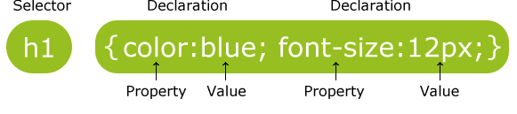

## The element Selector p { }

## The id Selector #menu{ }

## The class Selector .menu { }

# CSS Colors

Colors in CSS are most often specified by:

* a valid color name - like "red"
* an RGB value - like "rgb(255, 0, 0)"
* a HEX value - like "#ff0000"

• background-color

• background-image body {  
    background-image: url("paper.gif");  
}

background-repeat

body {  
    background-image: url("gradient_bg.png");  
    background-repeat: repeat-x;  
}

## Set position and no-repeat

body {  
    background-image: url("img_tree.png");  
    background-repeat: no-repeat;  
}

**Outline Style**

The outline-style property specifies the style of the outline.

The outline-style property can have one of the following values:

* dotted - Defines a dotted outline
* dashed - Defines a dashed outline
* solid - Defines a solid outline
* double - Defines a double outline
* groove - Defines a 3D grooved outline. The effect depends on the outline-color value
* ridge - Defines a 3D ridged outline. The effect depends on the outline-color value
* inset - Defines a 3D inset outline. The effect depends on the outline-color value
* outset - Defines a 3D outset outline. The effect depends on the outline-color value
* none - Defines no outline
* hidden - Defines a hidden outline

<html>

<body>

<table border=2px width=200px>

<tr><td colspan="2">A<sub>1</sub><sup>2</sup>+A<sub>2</sub><sup>2</sup></td></tr>

<tr><td width=>a </td><td rowspan="2" width=></td></tr>

<tr style="text-align:right;"><td width=>b</td></tr>

</table></body>

## Display: none;

display: none; is commonly used with JavaScript to hide and show elements without deleting and recreating them. Take a look at our last example on this page if you want to know how this can be achieved.

The <script> element uses display: none; as default.

## CSS Overflow

The CSS overflow property specifies whether to clip content or to add scrollbars when the content of an element is too big to fit in a specified area.

The overflow property has the following values:

* visible - Default. The overflow is not clipped. It renders outside the element's box
* hidden - The overflow is clipped, and the rest of the content will be invisible
* scroll - The overflow is clipped, but a scrollbar is added to see the rest of the content
* auto - If overflow is clipped, a scrollbar should be added to see the rest of the content

## The float Property

In its simplest use, the float property can be used to wrap text around images.

The following example specifies that an image should float to the right in a text:

### Example

img {  
    float: right;  
    margin: 0 0 10px 10px;  
}

## Transparent Image (jol sap)

The opacity property can take a value from 0.0 - 1.0. The lower value, the more transparent:

**Note:** IE8 and earlier use filter:alpha(opacity=x). The x can take a value from 0 - 100. A lower value makes the element more transparent.

### Example

img {  
    opacity: 0.5;  
    filter: alpha(opacity=50); /* For IE8 and earlier */  
}

## Transparent Hover Effect

img {  
    opacity: 0.5;  
    filter: alpha(opacity=50); /* For IE8 and earlier */  
}  
  
img:hover {  
    opacity: 1.0;  
    filter: alpha(opacity=100); /* For IE8 and earlier */  
}

## Dropdown Menu

<style>  
/* Style The Dropdown Button */  
.dropbtn {  
    background-color: #4CAF50;  
    color: white;  
    padding: 16px;  
    font-size: 16px;  
    border: none;  
    cursor: pointer;  
}  
  
/* The container <div> - needed to position the dropdown content */  
.dropdown {  
    position: relative;  
    display: inline-block;  
}  
  
/* Dropdown Content (Hidden by Default) */  
.dropdown-content {  
    display: none;  
    position: absolute;  
    background-color: #f9f9f9;  
    min-width: 160px;  
    box-shadow: 0px 8px 16px 0px rgba(0,0,0,0.2);  
    z-index: 1;  
}  
  
/* Links inside the dropdown */  
.dropdown-content a {  
    color: black;  
    padding: 12px 16px;  
    text-decoration: none;  
    display: block;  
}  
  
/* Change color of dropdown links on hover */  
.dropdown-content a:hover {background-color: #f1f1f1}  
  
/* Show the dropdown menu on hover */  
.dropdown:hover .dropdown-content {  
    display: block;  
}  
  
/* Change the background color of the dropdown button when the dropdown content is shown */  
.dropdown:hover .dropbtn {  
    background-color: #3e8e41;  
}  
</style>  
  
<div class="dropdown">  
  <button class="dropbtn">Dropdown</button>  
  <div class="dropdown-content">  
    <a href="#">Link 1</a>  
    <a href="#">Link 2</a>  
    <a href="#">Link 3</a>  
  </div>  
</div>

## Tooltip Examples

A tooltip is often used to specify extra information about something when the user moves the mouse pointer over an element:

# CSS3 Shadow Effects

* text-shadow
* box-shadow

h1 {  
    text-shadow: 2px 2px 5px red;  
}

## Rounded Images

Use the border-radius property to create rounded images:



### Example

Rounded Image:

img {  
    border-radius: 8px;  
}

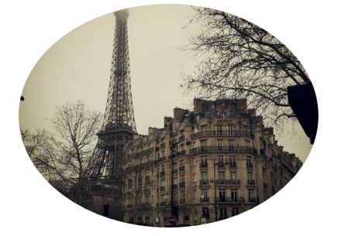

### Example

Circled Image:

img {  
    border-radius: 50%;  
}

# CSS Buttons

<!DOCTYPE html>

<html>

<head>

<style>

.button {

background-color: #4CAF50; /* Green */

border: none;

color: white;

padding: 15px 32px;

text-align: center;

text-decoration: none;

display: inline-block;

margin: 4px 2px;

cursor: pointer;

}

.button1 {font-size: 10px;}

.button2 {font-size: 12px;}

.button3 {font-size: 16px;}

.button4 {font-size: 20px;}

.button5 {font-size: 24px;}

</style>

</head>

<body>

<h2>Button Sizes</h2>

<p>Change the font size of a button with the font-size property:</p>

<button class="button button1">10px</button>

<button class="button button2">12px</button>

<button class="button button3">16px</button>

<button class="button button4">20px</button>

<button class="button button5">24px</button>

</body>

</html>

**Output:**

